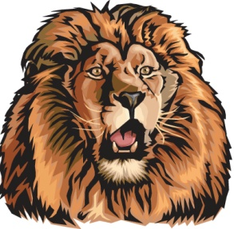
Darien Lions Club Foundation
1702 Plainfield Road Darien, Illinois 60561
www.darienlionsclubfoundation.org

DLCF Board Meeting Agenda – June 18, 2020 – House of Brunsen
2019-2020  President  Andrew Brunsen  Vice President  John Pearson  Secretary-Corresponding  Randy Porzel  Treasurer  Mike Falco  Secretary-Financial  Ed O’Conner  Committee Liaison  Brian Dahowski  Publicity  Steve Wernecke  Activities  Don Cozzolino  Membership  Steve Hiatt  Tail Twister  Greg Ruffolo  Ryan Walheim  Lion Tamer  Kevin Littwin  Past President  Ken Kohnke | Call to order – Lion President Andrew Brunsen  Committee Reports  - Special Needs – Lion Tom Weiland  - Flag Program - Lion Steve Hiatt  - Queen of Hearts Raffle – Lion Don Cozzolino  Secretary Report – Lion Randy Porzel  - May 2019 Board Meeting approval  - May 2019 Business Meeting review  Treasurer Report – Lion Mike Falco  - May 2019 Board Meeting approval  - May 2019 Business Meeting review  - Review of balances  President’s Report / Correspondence  Unfinished Business  New Business  Board Comments  - Andrew Brunsen  - John Pearson  - Randy Porzel  - Mike Falco  - Ed O’Conner  - Steve Hiatt  - Steve Wernecke  - Brian Dahowski  - Don Cozzolino  - Greg Ruffolo  - Ryan Walheim  - Kevin Littwin  - Ken Kohnke  Adjourn

