1702 Plainfield Road • Darien, Illinois 60561
www.darienlions.org ++ www.Facebook.com/DLCIL

DLC Dinner Meeting 50-20 Agenda – March 11, 2020 – Falco’s Pizza @ DSRC/ZOOM
2020-2021  President  John Pearson II  Vice President  Randy Porzel  Secretary-Corresponding.  Mike Falco  Treasurer  Ed O’Connor  Secretary-Financial  Paul Kempf  Committee Liaison  Ryan Walheim  Publicity  Ken Poindexter  Activities  Steve Wernecke  Membership  Wayne Scharnak  Tail Twister  Tom Pantoni  Ray Benaitis  Lion Tamer  Steve Hiatt  Past President  Andrew Brunsen | Call to order 7pm – Lion President John Pearson II  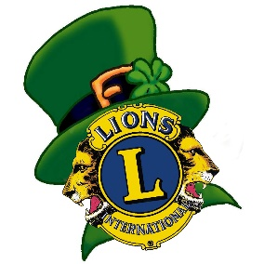  Pledge of Allegiance  Introduction of Guests  Sick and Visiting Report – Lion Lou Bedoe  Committee Reports  - Nominating – Lion Art Donner  - Pancake Breakfast 4/11 – Lion Mike Scheck  - Convention – Lion Doug Barnes  - Sight & Sound – Lion Ray Benaitis  - Big Raffle – Lion Art Kardatzke  - Golf Outing – Lion Andrew Brunsen  New Business  - ??????  Coming Events  - Spring Forward – change your clocks 1hr forward 3/14/2021  - Board Meeting 3/18/21 @ House of Pantoni/Zoom  - Business Meeting @ Chuck’s / Zoom (Vest Night) 3-25-2021  - Happy Easter 4/4/2021  - Dinner Meeting @ DSRC 4/8/2021 (TBA)  - Pancake Breakfast @ Chuck’s & DSRC 4/11/2021  - District 1J Virtual Convention 4/16 & 4/17  - 2020 Awards Night & 2021 Spring Induction @ Chuck’s / Zoom 4/23/2021 (date change from 4/22/2021)  Tail Twister’s – Lion Tom Pantoni and Lion Ray Benaitis  Invocation – Lion John Pearson  Adjourn

