1702 Plainfield Road • Darien, Illinois 60561
www.darienlions.org ++ www.Facebook.com/DLCIL

DLC Board Meeting Agenda – Oct 17, 2019 – Home of Ed O’Connor
2013-2014  President  Andrew Brunsen  Vice President  John Pearson  Secretary-Corres.  Randy Porzel  Treasurer  Mike Falco  Secretary-Financial  Ed O’Connor  Committee Liaison  Brian Dahowski  Publicity  Steve Wernecke  Activities  Don Cozzolino  Membership  Steve Hiatt  Tail Twister  Greg Ruffolo  Ryan Wahlehim  Lion Tamer  Kevin Litwin  Past President  Ken Kohnke | Call to order 7pm – Lion President Andrew Brunsen  Pledge  Committee Reports  - Candy Day – Lion Bill O’Malley  - Candy Day Business – Lion John Pearson  - Halloween Party – Lion Steve Werenecke  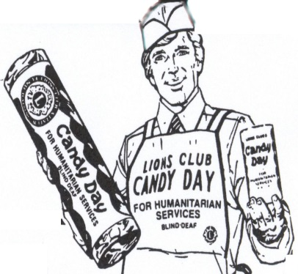  - Food Baskets – Lion Brian Rzepka  Membership Report – Lion Steve Hiatt  Secretary (Financial) Report – Lion Ed O’Connor  - Review dues collections, how many unpaid  Secretary Report – Lion Randy Porzel  - September 19, 2019 Board for approval  - September 26, 2019 Business for review  - October 10, 2019 Dinner for review  Treasurer Report – Lion Mike Falco  - September 2019 for approval  Publicity – Lion Steve Wernecke  President’s Report / Correspondence  - Peace Poster  - Thank You Notes  - November Calendar Changes  Unfinished Business  New Business  - SE Zone Meeting 11-13-2019 @ Grand Dukes, we sponsor  - Lions of Illinois Foundation Gala – Lion Jim Kiser  - Resolution to endorse Lion Jim Kiser for 2nd District Governor  Coming Events  - Business Meeting @ CGCC 10-24-2019 Vest Night  - Halloween Party @ Sportsplex 10-31-2019  - Dinner Meeting @ DSRC 11-7-2019  - SE Zone Meeting @ Grand Dukes 11-13-2019  - Board Meeting @ House of Ruffolo 11-14-2019  - Business Meeting @ CGCC 11-21-2019 Vest Night  - Happy Thanksgiving all day 11-28-2013  Board Comments  - John Pearson  - Randy Porzel  - Mike Falco  - Ed O’Connor  - Steve Hiatt  - Steve Wernecke  - Don Cozzolino  - Greg Ruffolo  - Ryan Walheim  - Brian Dahowski  - Kevin Litwin  - Ken Kohnke  Adjourn

