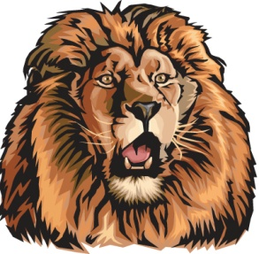
Darien Lions Club Foundation
1702 Plainfield Road Darien, Illinois 60561
www.darienlionsclubfoundation.org

DLCF Business Meeting 50-10 Agenda – November 19, 2020 – Zoom
2020-2021  President  John Pearson II  Vice President  Randy Porzel  Secretary-Corresponding.  Mike Falco  Treasurer  Ed O’Connor  Secretary-Financial  Paul Kempf  Committee Liaison  Ryan Walheim  Publicity  Ken Poindexter  Activities  Steve Wernecke  Membership  Wayne Scharnak  Tail Twister  Tom Pantoni  Ray Benaitis  Lion Tamer  Steve Hiatt  Past President  Andrew Brunsen | Call to order – Lion President John Pearson  Committee Reports  - Queen of Hearts – Lion Greg Ruffolo  - Food Baskets – Lion Greg Ruffolo  - Flag Program – Lion Steve Hiatt  - Special Needs – Lion Tom Wieland  - Halloween Trunk or Treat - Lion Ivan Herchenbach  - Foundation Advisory – Lion Randy Porzel  Secretary Report –Lion Mike Falco  - October 15, 2020 Board for Review  - October 22, 2020 Business for Approval  Treasurer Report –Lion Ed O’Conner  - October 2020 for Approval  President’s Report  - Special Thank You for Flag Program  - Amazon Smile $34.05 donation from the Amazon Smile Foundation as a result of Amazon Smile program activity between July 1 and September 30, 2020.  Correspondence  Unfinished Business  New Business  Adjourn

