1702 Plainfield Road • Darien, Illinois 60561
www.darienlions.org ++ www.Facebook.com/DLCIL

DLC Non-Smoker Dinner Meeting Agenda – Jan 24, 2020 – DS&RC
2019-2020  President  Andrew Brunsen  Vice President  John Pearson  Secretary-Corres.  Randy Pearson  Treasurer  Mike Falco  Secretary-Financial  Ed O’Connor  Committee Liaison  Brian Dahowski  Publicity  Steve Wernecke  Activities  Don Cozzolino  Membership  Steve Hiatt  Tail Twister  Greg Ruffolo  Ryan Walheim  Lion Tamer  Kevin Littwin  Past President  Ken Kohnke | 49-13  Call to order 7pm – Lion President Andrew Brunsen  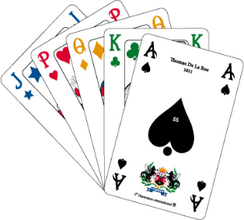  Pledge of Allegiance  Introduction of Guests  Sick and Visiting Report – Lion Lou Bedoe  Committee Reports Extremely Short  - Blood Drive – Lion Steve Wernecke  Still narrowing down the dates. More info to come  - Big Raffle – Lion Dave\  Tickets are available. See your captains  - Sight & Sound – Lion Mark Piccoli  Tickets are available  $10 per book (3 tickets)  If you sell 2 books, you will be entered into a raffle to win a big raffle ticket.  Tail Twister’s – Lion Greg Ruffolo & Lion Ryan Walheim  Invocation –  Coming Events  - SE Zone Meeting 2-5-2020 – Zazzo’s Westmont  - Dinner Meeting @ Malahini Terrace 2-13-2020  - Board Meeting @ House of Pearson 2-20-2020  - Business Meeting @ CGCC 2-27-2020 Vest Night  - Pancake Breakfast @ Eisenhower 3-8-2020  - Blood Drive @ Eisenhower 3-10-2020  Adjourn

