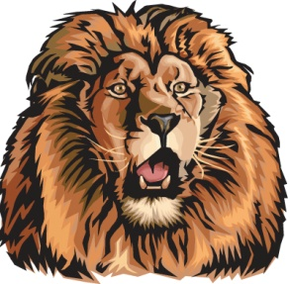
Darien Lions Club Foundation
1702 Plainfield Road Darien, Illinois 60561
www.darienlionsclubfoundation.org

DLCF Board Meeting 50-21 MINUTES – March 18, 2021 – House of Pantoni/Zoom
2020-2021  President  John Pearson II  Vice President  Randy Porzel  Secretary-Corresponding.  Mike Falco  Treasurer  Ed O’Connor  Secretary-Financial  Paul Kempf  Committee Liaison  Ryan Walheim  Publicity  Ken Poindexter  Activities  Steve Wernecke  Membership  Wayne Scharnak  Tail Twister  Tom Pantoni  Ray Benaitis  Lion Tamer  Steve Hiatt  Past President  Andrew Brunsen | Call to order – Lion President Andrew Brunsen  Committee Reports  - Queen of Hearts – Lion Greg Ruffolo  Restart selling and drawing may 3rd  Looking for sellers  - Flag Program – Lion Steve Hiatt  3rd week of April, all hands meeting at shed to repair flags  - Special Needs – Lion Tom Wieland  Going well  - Halloween Trunk or Treat (FINAL) - Lion Ivan Herchenbach  - Scholarships – Lion Ron Kiefer  DG south- no formal ceremony  - Foundation Advisory Committee – Lion Andrew Brunsen  Repurposing foundation strategy  6 year avg, 37k per year from foundation to club activities  4-5% annual growth will give the foundation the means to fund the club activities while continuing to grow the foundation  Secretary Report –Lion Mike Falco  - February 2021 Board for approval  - February 2021 Business for review  Treasurer Report –Lion Ed O’Connor  - February 2021 for approval  President’s Report  Unfinished Business  New Business  Board Comments  - Randy Porzel  - Mike Falco  - Ed O’Connor  - Paul Kempf  - Ryan Walheim  - Ken Poindexter  - Steve Wernecke  - Wayne Scharnak  - Tom Pantoni  - Ray Benaitis  - Steve Hiatt  - Andrew Brunsen  Adjourn

