1702 Plainfield Road • Darien, Illinois 60561
www.darienlions.org ++ www.Facebook.com/DLCIL

DLC Board Meeting 50-6 Agenda – Oct 15, 2020 – Home of Lion Doug Barnes for Lion Paul Kempf
2020-2021  President  John Pearson II  Vice President  Randy Porzel  Secretary-Corresponding.  Mike Falco  Treasurer  Ed O’Connor  Secretary-Financial  Paul Kempf  Committee Liaison  Ryan Walheim  Publicity  Ken Poindexter  Activities  Steve Wernecke  Membership  Wayne Scharnak  Tail Twister  Tom Pantoni  Ray Benaitis  Lion Tamer  Steve Hiatt  Past President  Andrew Brunsen | Call to order 6:30 pm – Lion President John Pearson II  Pledge  Committee Reports  - Candy Day – Lion Hugh Hardman  - Candy Day Business – Lion Brian Kiefer  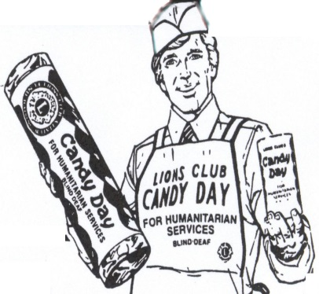  - Blood Drive – Lion Steve Wernecke  Membership Report – Lion Wayne Scharnak  - Directories (getting them out to membership)  Secretary (Financial) Report – Lion Paul Kempf  - Review dues collections, how many unpaid  Secretary Report – Lion Mike Falco  - September 17, 2020 Board for approval  - September 24, 2020 Business for review  - October 8, 2020 Dinner for review  Treasurer Report – Lion Ed O’Conner  - September 2020 for approval  Publicity – Lion Ken Poindexter  President’s Report / Correspondence  - Ransom details  - Board Meeting (winter)  - District 1J Golf Outing-Lion Steve/Lion Jim  - MyLci Membership Update  Unfinished Business  - Our Lady of Peace food pantry, food drive – Lion Andrew Brunsen  - Darien Lions Club Apparel – Lion Andrew Brunsen  - Eagle Scout Projects updates ( Lucas Cunningham, Kevin Schoeberle, Dean Spicuzza) – Lion Kerry Spitznagle  New Business  - Resolution to endorse Lion Jim Kiser for 1st District Governor  - Eagle Scout Project (Dustin Cerny) – Lion Kerry Spitznagle  Coming Events  - Business Meeting (Vest Night) @ Chuck’s 10-22-20  - Darien Chamber Golf Outing @ CGCC 10-24-20  - OLP Food Drive @ OLP 10-24-20 9:00am until Noon  - Halloween Trunk or Treat @ DSRC 10-31-20  - Dinner Meeting – 11-5-20 @ TBA  - Board Meeting @ DSRC (Lion Steve Wernecke) 11-12-20  - Business Meeting @ Chuck’s (Vest Night) 11-19-20  - Happy Thanksgiving 11-26-20  - Blood Drive @ CGCC 12-9-20 3pm until 7pm  - MD1 Forum – TBA  - SE Zone Meeting - @ TBA 12-2-20  Board Comments  - Randy Porzel  - Mike Falco  - Ed O’Connor  - Paul Kempf  - Ryan Walheim  - Ken Poindexter  - Steve Wernecke  - Wayne Scharnak  - Tom Pantoni  - Ray Benaitis  - Steve Hiatt  - Andrew Brunsen  Adjourn

