www.darienlions.org ++ www.Facebook.com/DLCIL

DLC Induction/Dinner 50-5 MINUTES – October 8, 2020 – Chuck’s
2020-2021  President  John Pearson II  Vice President  Randy Porzel  Secretary-Corresponding.  Mike Falco  Treasurer  Ed O’Connor  Secretary-Financial  Paul Kempf  Committee Liaison  Ryan Walheim  Publicity  Ken Poindexter  Activities  Steve Wernecke  Membership  Wayne Scharnak  Tail Twister  Tom Pantoni  Ray Benaitis  Lion Tamer  Steve Hiatt  Past President  Andrew Brunsen | Call to order 6:30pm – Lion President John Pearson II  Pledge –  Introduction of Guests  - New members and Spouses  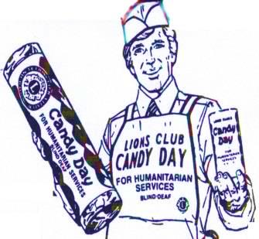  Sick and Visiting – Lion Lou Bedoe  - Dave Rickert  - Julio Check  Candy Day – Lion Hugh Hardman  - Full Virtual Event  - Email for Electronic Donations, Paypal with a QR code  - Looking to raise 8-10 K  Candy Day Business – Lion Brian Kiefer  - Looking to Raise 4-6 K in Corporate Sponsors  Corporate Events- Culvers, Chucks, Bouna Beef, Falcos  Induction of New Members – Lion Greg Ruffolo and Lion Rick Biehl  - Leslie Sweeney - Sponsor Lion Kerry Spitz  - Tracy Thomspon Johnson- Sponsor Lion Joe Marchese  - Shari Gillespie- Sponsor Lion Steve Wernecki  - Derek Hughes- Sponsor Lion Steve Hiatt  - Michael Fields- Sponsor Lion Tom Sailer  - Dan Golden- Sponsor Lion Art Kardatzke  Secret Award – District 1J Representative  - Scouting Service award presented to Lion Kerri Spitznagle  Membership – Lion Wayne Scharnak  Unfinished Business – none for this meeting  New Business  - Our Lady of Peace food pantry, food drive – Lion Andrew Brunsen  - “Stuff a Pod” food/donation drive @ OLP  - Darien Lions Club Apparel – Lion Andrew Brunsen  - Order form sent out  - Darien Chamber Golf Outing – Hole Sponsor $100  Coming Events  - Candy Day weekend 10-10-20  - Board Meeting @ Lion Doug Barnes (Lion Paul Kempf) 10-15-20  - Business Meeting (Vest Night) @ Chuck’s 10-22-20  - Darien Chamber Golf Outing @ CGCC 10-24-20  - Halloween Trunk or Treat @ DSRC 10-31-20  - Dinner Meeting – 11-5-20 @ TBA  - MD1 Forum – TBA  - SE Zone Meeting - @ TBA 12-2-20  Invocation –  Tail Twister Raffle – Lions Tom Pantoni & Ray Benaitis  Adjourn

