1702 Plainfield Road • Darien, Illinois 60561
www.darienlions.org ++ www.Facebook.com/DLCIL

DLC Induction/Dinner Minutes – October 10, 2019 – Bohemian Crystal
2019-2020  President  Andrew Brunsen  Vice President  John Pearson  Secretary-Corresponding  Randy Porzel  Treasurer  Mike Falco  Secretary-Financial  Ed O’Connor  Committee Liaison  Brian Dahowski  Publicity  Steve Wernecke  Foundation Liason  Don Cozzolino  Membership  Steve Hiatt  Tail Twister  Greg Ruffolo  Ryan Walheim  Lion Tamer  Kevin Littwin  Past President  Ken Kohnke | 49-4  Call to order 6:30pm – Lion President Andrew Brunsen  Pledge  Introduction of Guests  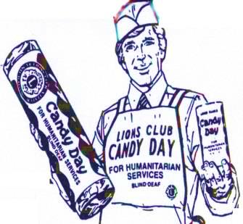  Sick and Visiting – Lion Lou Bedoe  Candy Day – Lion Bill O’Malley  Everything in order for tomorrow  Need more volunetters  Candy Day Business – Lion John Pearson - None  Induction of New Members – Lion Greg Ruffolo and Lion Rick Biehl  - Inducted 2 members  - Jim Heavey  - Mike Fejreega  Unfinished Business – none for this meeting  New Business --  Coming Events  - Candy Day 10-11 and 10-12-2019 sun up to sun down  - Board Meeting @ House of O’Connor 10-17-19  - Business Meeting @ CGCC 10-24-2019 Vest Night  - Halloween Party @ Sportsplex 10-31-2019  - Dinner Meeting @ DSRC 11-7-2019  - SE Zone Meeting @ TBD 11-13-2019  - Board Meeting @ House of Ruffolo 11-14-2019  Invocation –  Tail Twister Raffle – Lions Greg Ruffolo & Lion Ryan Walheim  Adjourn

